Day 2 : Test Suites & Test Case Design
Learnt
- Test Suite structure
  - In Single Repository mode, TestRail has one default Test Suite.
  - This suite contains all test cases for the application.
  - Think of it as:
Application → Test Suite → Sections → Test Cases
Example:
Veeva Vault – QA (Project)
└── Test Suite (Single Repository)
├── Login
├── User Management
├── Document Management
├── Workflows
├── Security & Access Control
- Section-based organization
A Section is a logical grouping of related test cases, usually by:
- Feature
- Module
- Functional area
- Test case fields:
  - Preconditions
  - Steps
  - Expected Results
  - Priority, Type
Practical
- Created Test Suites:
  - Login
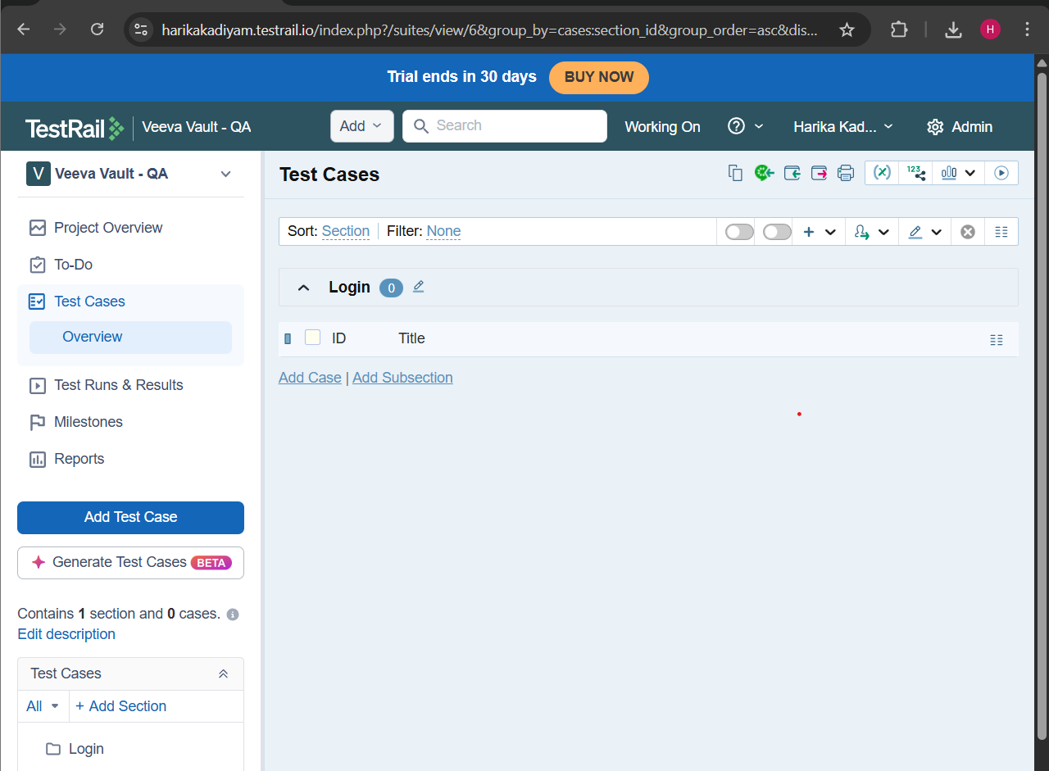
  - User Management
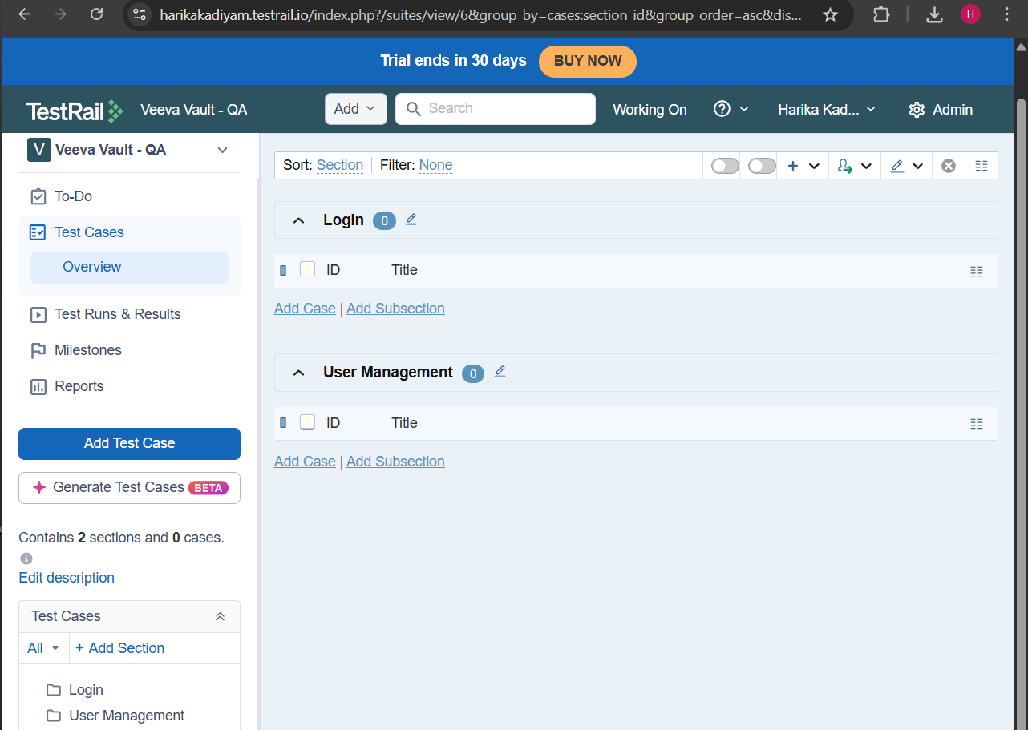
- Created 8 manual test cases each
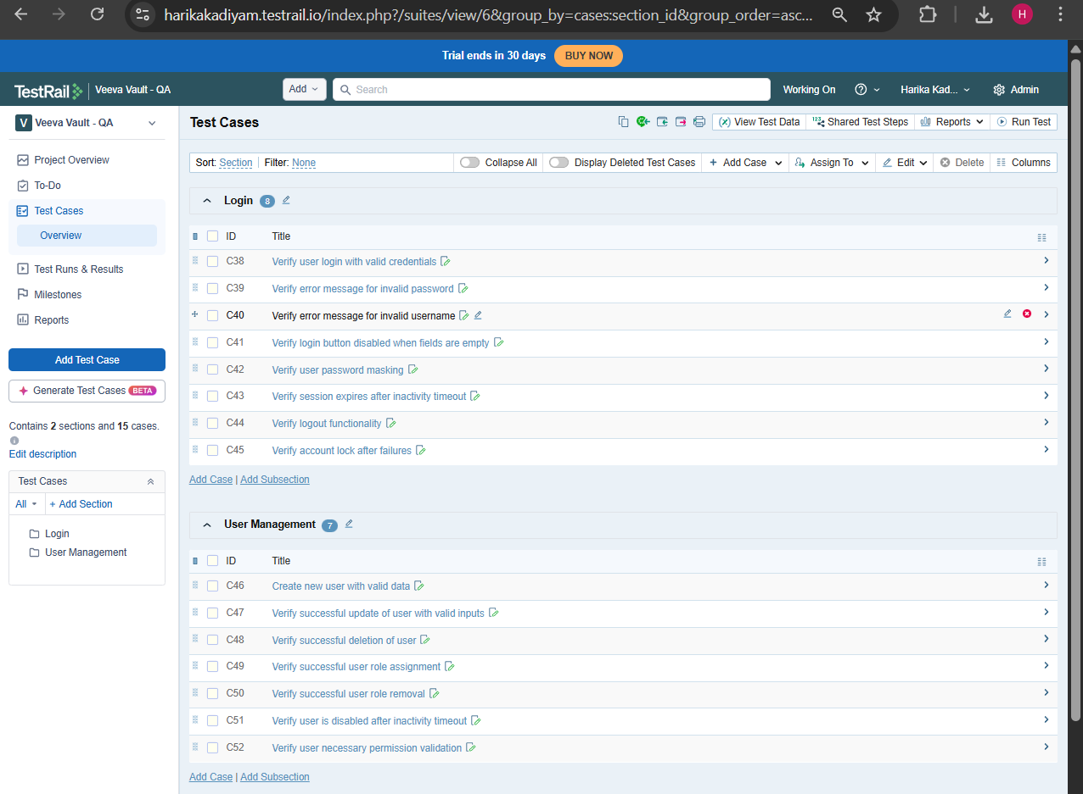
- Used:
  - Steps format
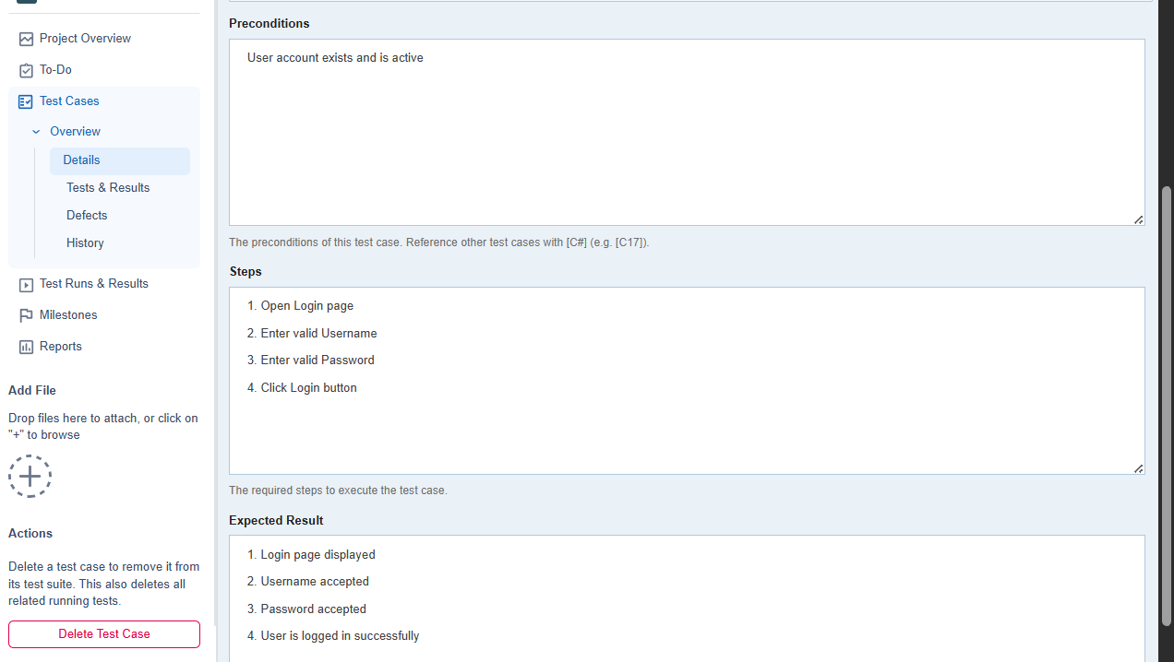

  - Priority levels
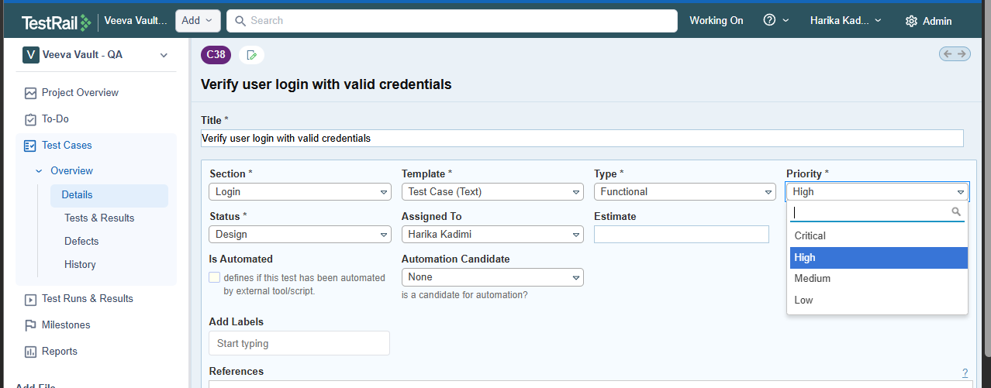
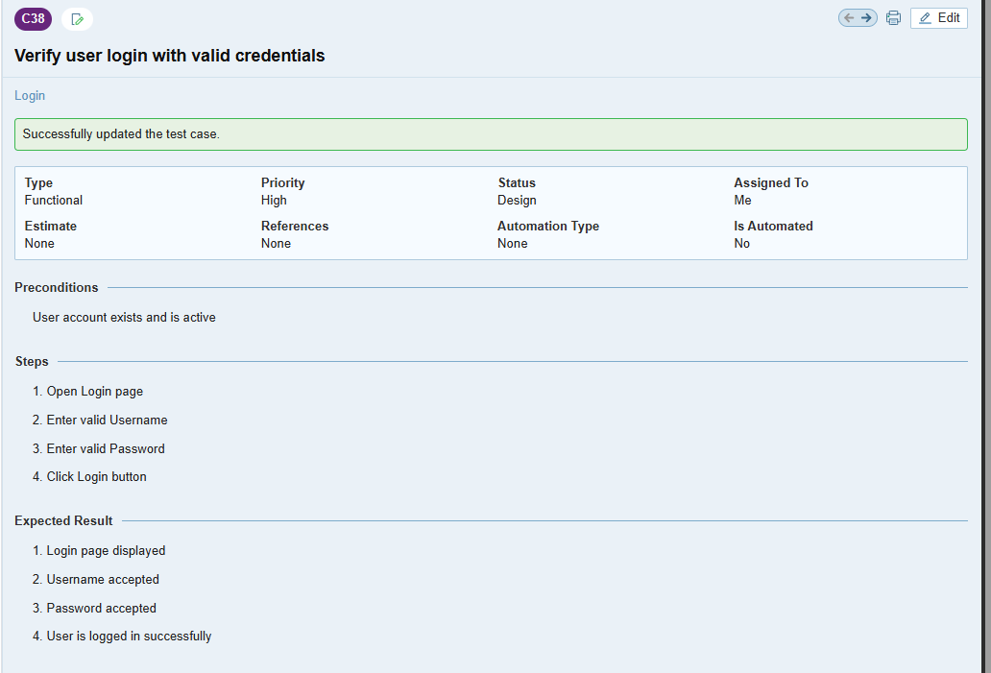
- Edited, cloned, and deleted test cases
- Edit option

- Before editing
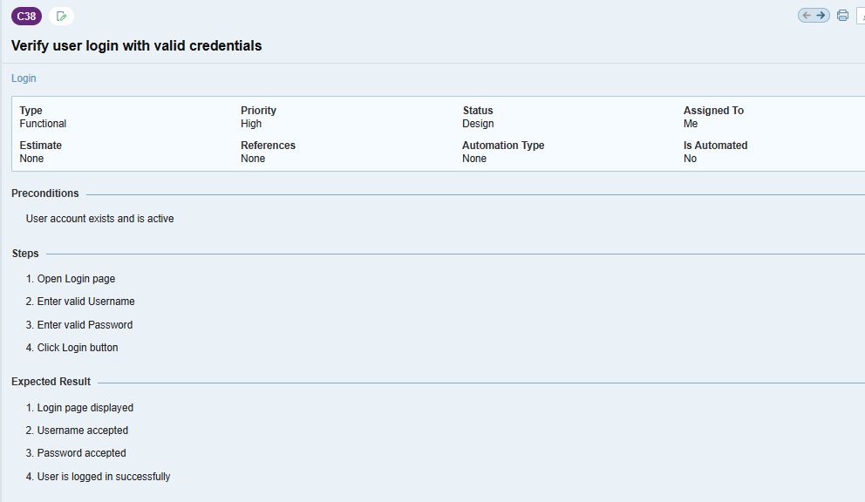
- After editing Priority and Expected Results
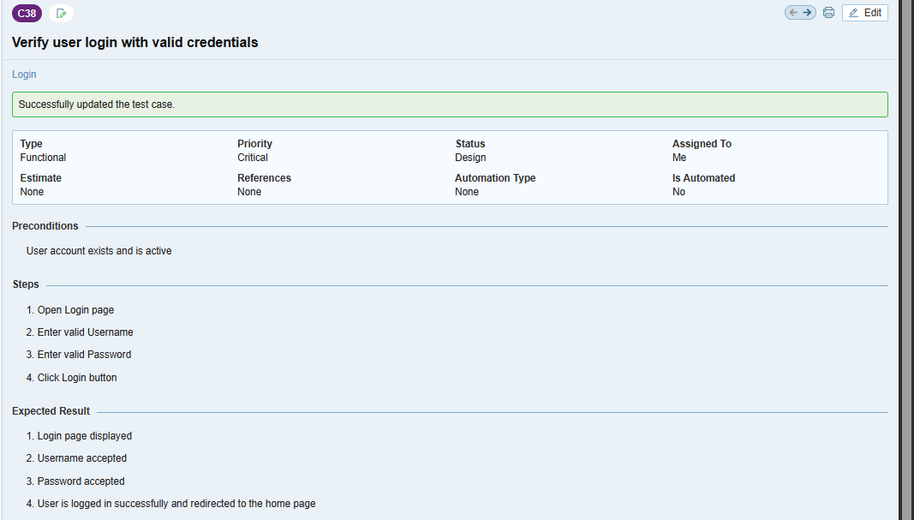
- Cloning a test case

Or
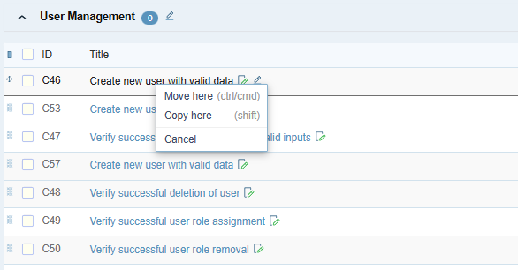
- After cloning
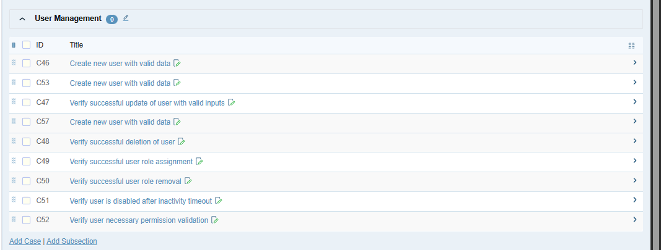
- After Updating
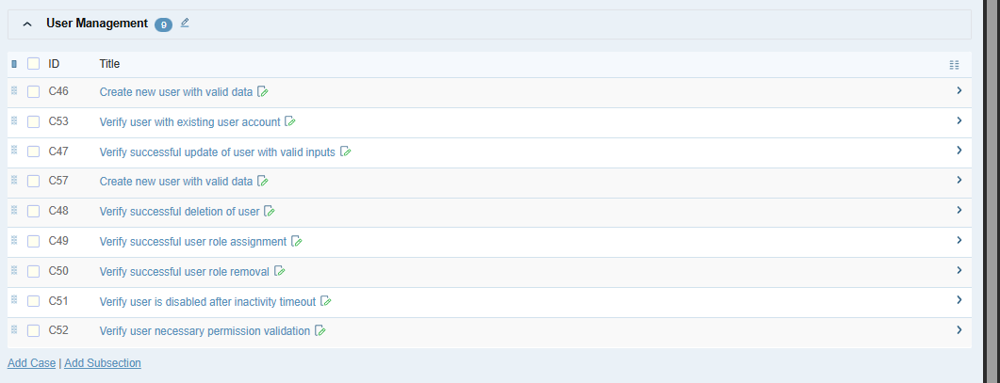

- Deleting the test case
